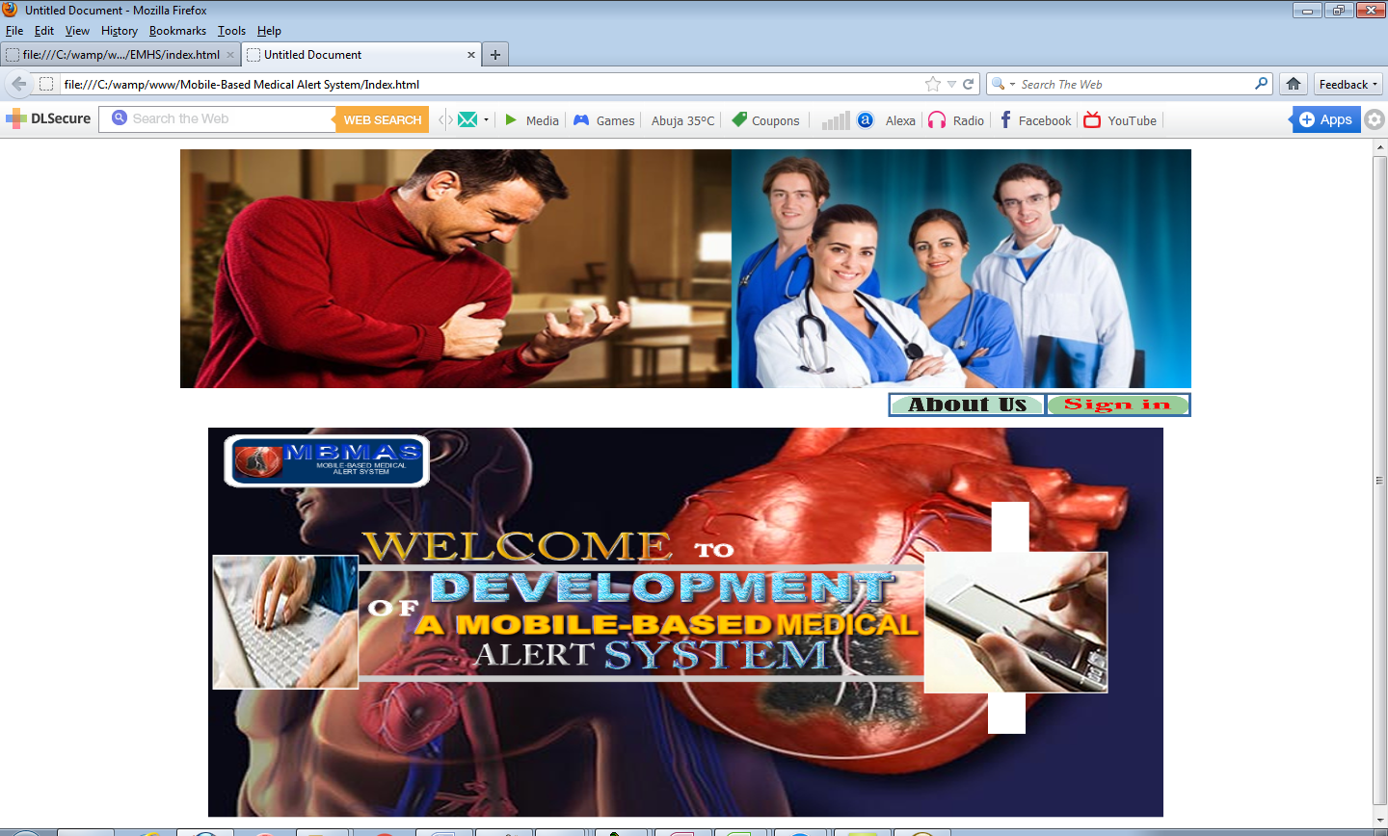

Fig. 1. Home page

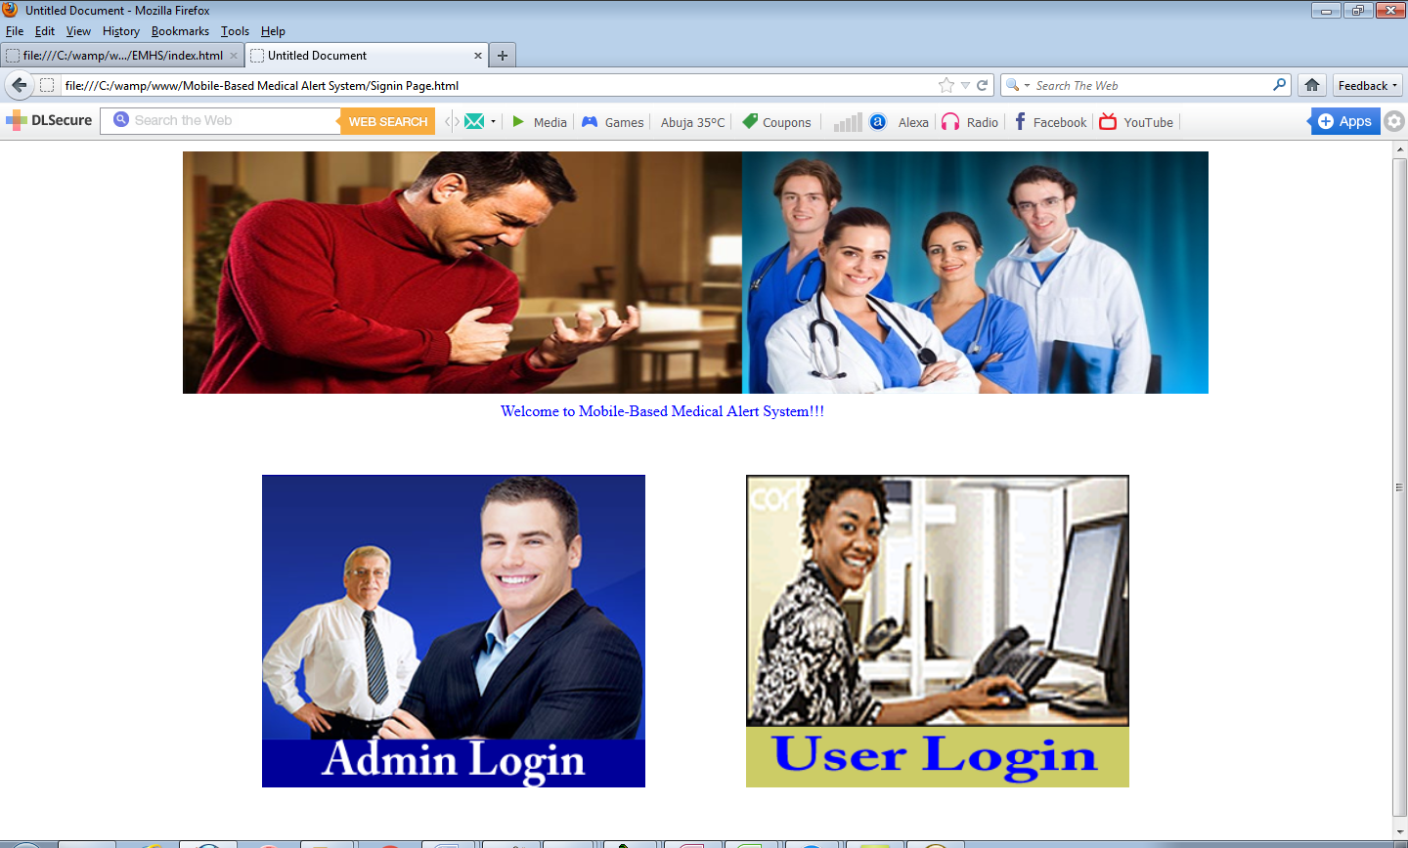

Fig. 2: Sign in Page

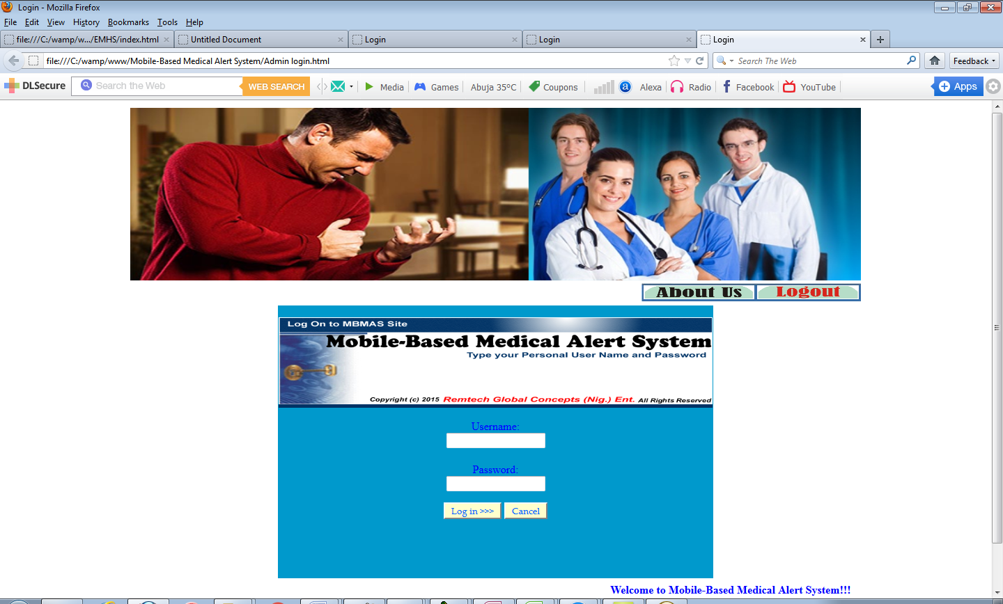

Fig. 3: User and Admin Login Page

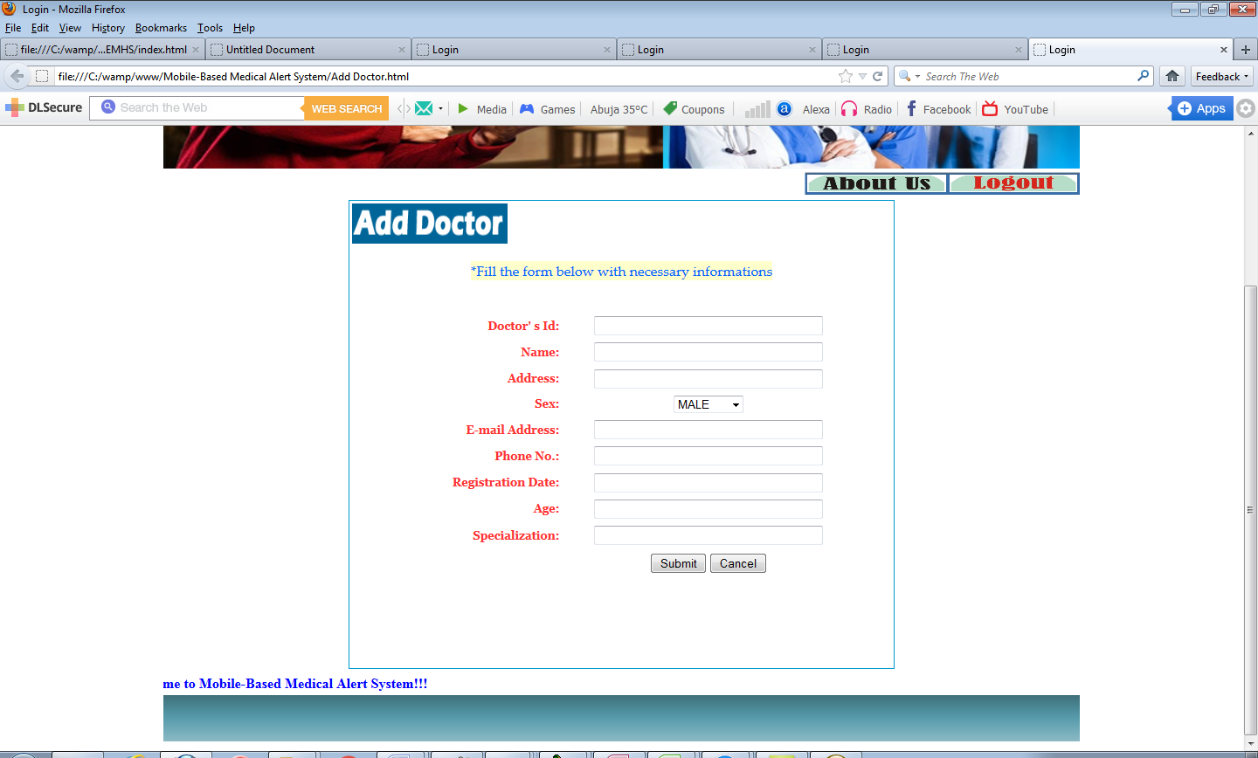

Fig. 4: Add Doctor Page

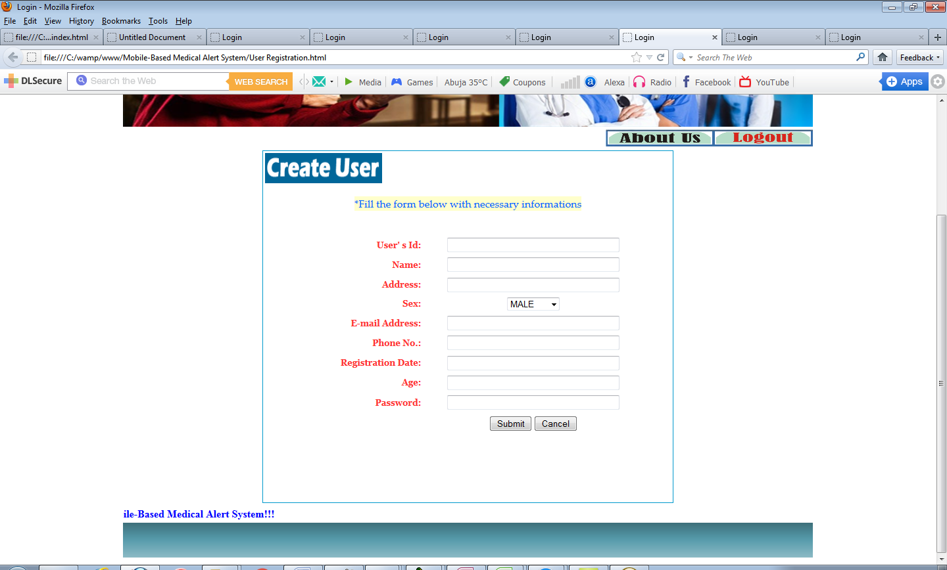

Fig. 5: User(Patient) Registration Page

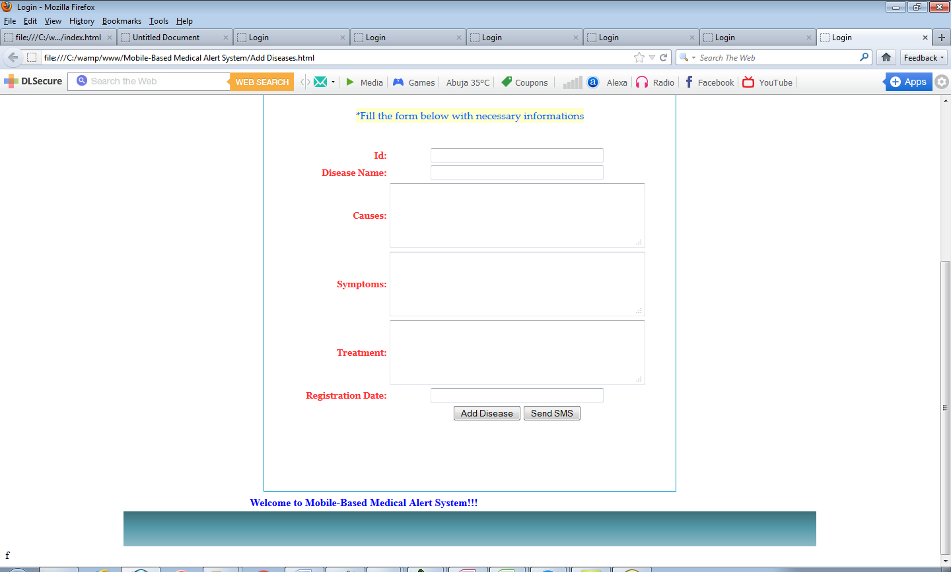

Fig. 6: Add Diseaseand Send SMS Page

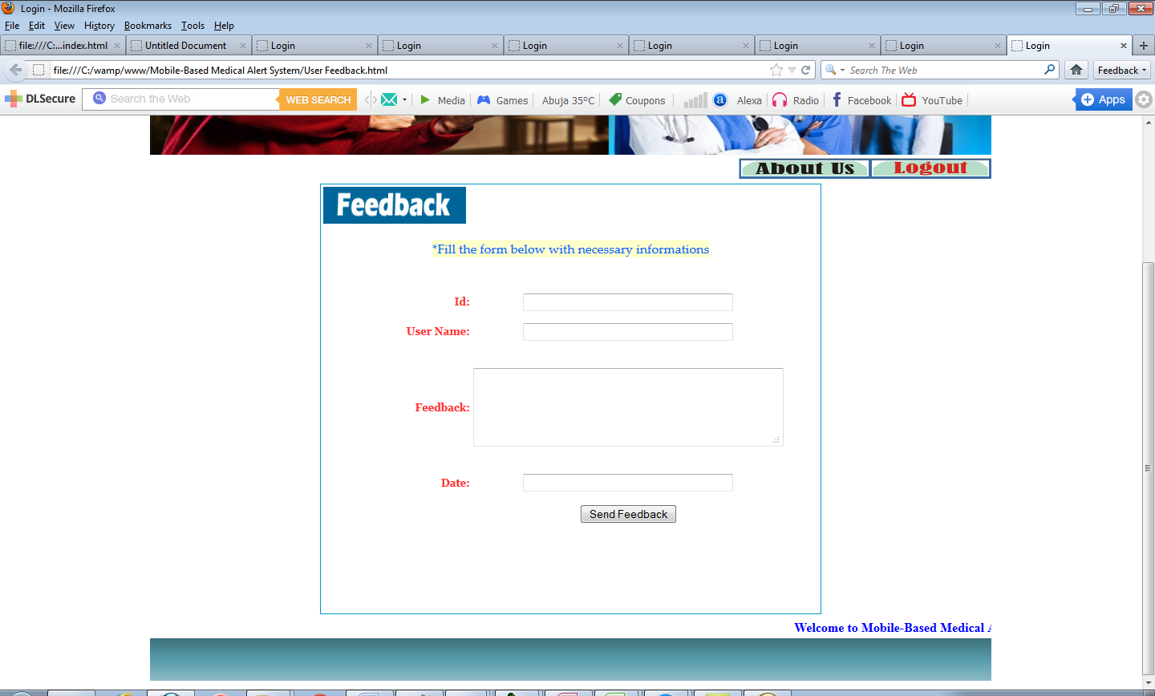

Fig. 7: User Feedback